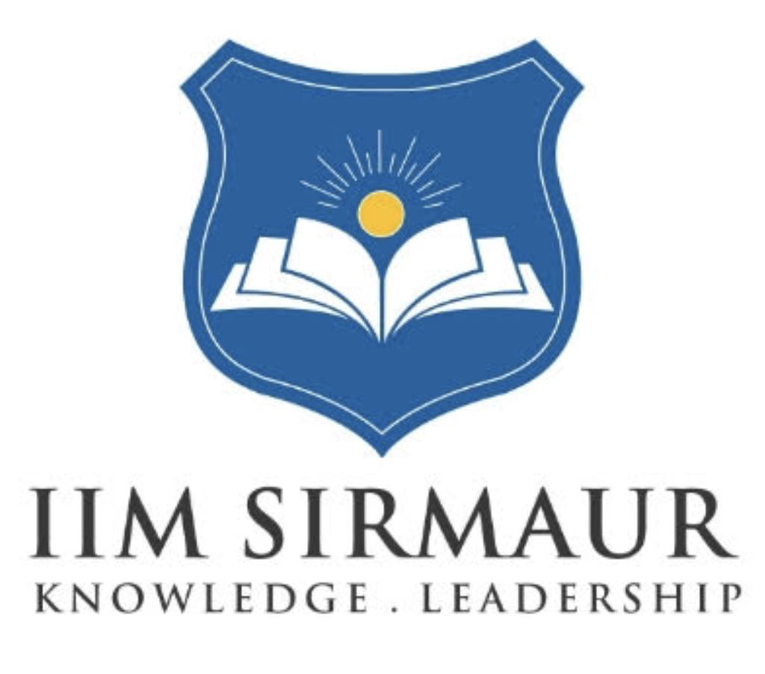
INDIAN INSTITUTE OF MANAGEMENT SIRMAUR
Management Development Program for Women Entrepreneurs
on
“Strengthening Eco-Social Enterprises”
November 3-5, 2025
Program Schedule
3rd November 2025 (Monday) - DAY 1 - Fundamentals of IoFE, Producer company and Gender
Session No | Timing | Details | Resource Person
1. | 10:30-11:15 AM | Introduction | Amit
 | 11:15- 11:30 AM | Break
2. | 11:30-1:00 PM | Initiative on Forest Economy (IoFE) | Satya Prasanna
 | 1:00-2:00 PM | Lunch Break
3. | 2:00-3:30 PM | Concept of Producer Company | Advaita and Amit
 | 3:30-3:45 PM | Break
4. | 3:45-5:15 PM | Community Enterprise: Through Gender lens | Jayanti

4th November 2025 (Tuesday) - DAY 2 Business Operations of Producer Company

Session No. | Timing | Session Details | Resource Person
5. | 9:30-11:00 AM | Sales learnings from Pangi PPJPC | Yamini + PPJPC members
 | 11:00- 11:15 AM | Break
6. | 11:15-12:15 PM | Concepts on Producer Companies and fair price distribution to the Primary Collectors | Advaita
7. | 12:15 PM - 1:15 PM | Entrepreneurship through Effectuation | Ujjwal
 | 1:15 PM -2:15 PM | Lunch Break
8. | 2:15-3:15 PM | Team Building | Parijat
 | 3:30-3:45 PM | Break
9. | 3:45-5:15 PM | Forest Management and Community enterprises | Satya Prasanna
10. | 5:15 PM onwards | Open Discussion on learnings of last two days | Neha

5th November 2025 (Wednesday) - DAY 3 - Success Stories
Session No. | Timing | Session Details | Resource Person
11. | 9:30 - 10:00 AM | IIM Sirmaur Interaction | CMDP Chairperson + Faculty
12. | 10:00-11:00 AM | Success Stories from different States- Jharkhand, and Odisha sale and Maharashtra enterprises | Jayanti and Santosh
 | 11:00- 11:15 AM | Break
13. | 11:15 AM - 1:15 PM | Planning exercise for PCs- Group work | Amit and Yamini
 | 1:15 PM -2:00 PM | Lunch Break

2

